# Reordering Sunglasses for an Online Retailer

#### The Problem

An online retailer has been selling a certain model of sunglasses during the last four years. The retailer receives the sunglasses from a manufacturing plant in China, and once an order is placed it takes 3 months on average until the product arrives at the main warehouse. For operational reasons, only one order can be placed per month and must always be placed the first day of the month.

We have the sales data of the sunglasses for the last 4 years.

We know the current stock level and also the stock that will arrive during the following months (stock in transit).

We have also been provided the following information but we are not sure we really need it:

Manufacturing Cost = 10 €

Selling Price = 25 €

Holding Cost = $0.25 / Unit and Month (This is an estimated cost related to the use of the warehouse and the insurance of the stock)

Financial Costs 5% TIN (The retailer buys the product using a credit line with that interest)

**The retailer wants to know how many units of sunglasses they should buy in the next order.**

The code of the current solution looks like this:

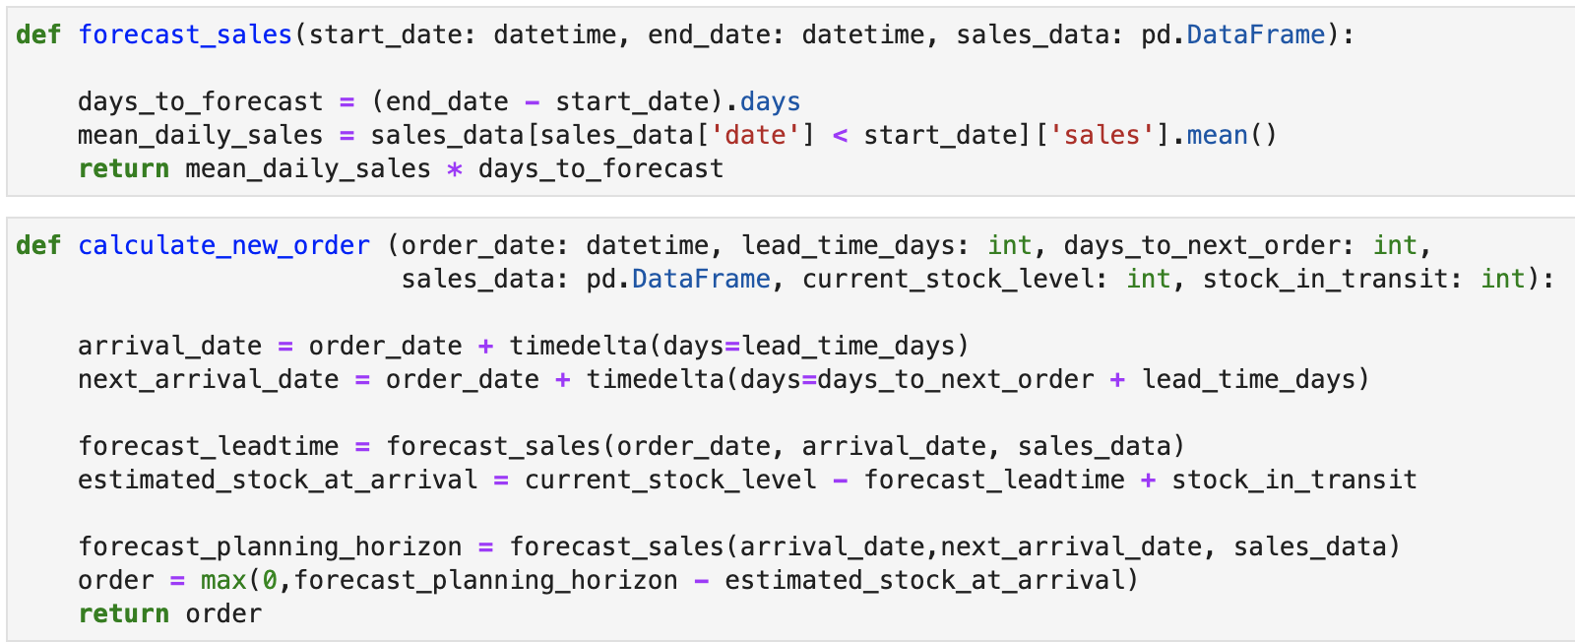

You can find the code of the current solution in the attached document “ds_test.ipynb” and the sales data in “sales_data.csv”

**Your main task consists of showing us how you would improve this solution**

**What are we expecting from you?**

Building a DS model is always a trade-off between complexity and accuracy/optimality. With this in mind, we leave the problem above to be very open ended. There are plenty of opportunities to go deep in the forecast model, in the decision optimisation, in the programming, etc. We understand that a complete solution could imply quite a bit of work, and our intention is not to see just how much work you are willing to do. On the contrary, we want you to think about the problem and make some improvements in the current solution, focus on what you think is more important, and show us how you would reason through it. **We don’t expect you to invest more than two hours**. You will have the opportunity to explain additional solutions and improvements during the interview process.

At Nextail, we make every effort to evaluate each candidate as a whole, so please remember no one would be rejected just because of this test. Our aim is to better understand how you tackle problems with limited time, allowing us to have a much more interesting conversation during the technical interview.

**Deploy your solution to production:**

Imagine your prototype has been approved and your code needs to be used in production, validated, used and maintained by other developers and data scientists. We want to see how you would adapt and improve your first solution to be used in production.Just as above, we are curious about how you would improve the design, robustness, readability and maintainability of your code going from a script to production code. A small refactoring or adding a test should be enough. Please do not spend a ton of time on this.

#### Send us:

* The final code of your solution.

And optionally, (just if you think it makes sense):

* Your final result.
* A text explanation with anything you want clarify about the solution:
  + Anything you didn’t have the time to implement but is part of your solution.
  + The possible evolution of the model.
  + The criteria / metrics / process that will help you to decide when to stop improving the model.
* Any visuals you think may help to understand your modelling of the problem and/or the algorithms used to solve it (nothing fancy a handmade drawing is enough).
* The code of your initial solution (before you improved it for production). Send your code as a git repo so we can see how you incrementally improve your code.

Please do not hesitate to reach out to us if you have any questions or if you would like to clarify any part of the instructions.

#### 

#### Next Interview

We see this test as an excuse to talk about the details of solving a data science problem. Before going into the detail of your solution we will ask you to explain your model as you would to a non-technical user. Next we will be discussing your solution, how you think it might evolve, and how would you face the challenges to come.